TEACHER:MWALE CHIPO

DESIGN AND TECHNOLOGY DEPARTMENT LESSON PLAN

SUBJECT: DESIGN AND TECHNOLOGY CLASS:…… … DATE:……/……./20…. DURATION:………….
BOYS:…………………… GIRLS ………………………………………. TOTAL OF PUPILS… TOPIC: BASIC INSTRUMENTS TOOLS SUBTOPIC: BASIC INSTRUMENTS TOOLS

LEARNING OUTCOMES LSBAT
- Identify basic tools that are used in graphical communication
- Types of lines that are used in graphical communication
RATIONALE
Knowledge: Instruments used in graphical communication
Skills: Application of instruments
Values: Awareness of using Set Square when drawing lines

TEACHING AIDS
Actual instruments, chalk board
PART | LESSON CONTENT | METHODOLO GY | LEARNER ACTIVITY
introducti on | - Recap on the previous lesson | Questions and answers | Provide answers
Development | BASIC INSTRUMENTS TOOLS  - Pencils = (6H) can be used for light lines, a softer pencil (2H) for the outlines  - Ruler  - Set squares (60 ° and a 45 ° set square)  - Rubber  - Compasses  - Dividers  - Drawing board  - T-square  - Clips or tape  TYPES OF LINES USED IN CONSTRUCTION  - Construction (Fent) line  - Outlines  - Hidden lines  - Section line  - Centre lines | Questions And Answers  Demonstration  V/E | Taking note of important points  Provide answers
Applicati on | CLASS EXERCISE  - Mention any 6 basic instrument tools  - Mention five types of line used in drawing | Questions And Answers | Provide answers
Conclusi on | - Recap on the main steps and points | V/E

- Draw board line and tittle block
RATIONALE
Knowledge: Boarder lines (10 mm around) and tittle block, lettering
Skills: Construction of boarder’s liner and tittle block
Values: Awareness of the standard way of preparing drawing paper.
TEACHING AIDS
PART | LESSON CONTENT | METHODOLO GY | LEARNER ACTIVITY
introduction | - Recap on the previous lesson | Questions and answers | Provide answers
Developme nt | BOARD LINE AND TITTLE BLOCK  - Boarder lines (10 mm around)  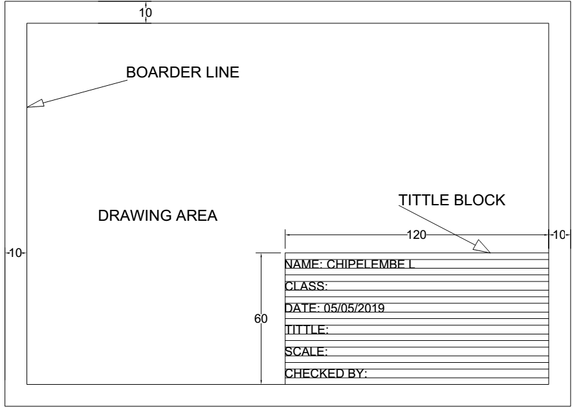  LETTERING  A B C D E F G H I J K L M N O P Q R S T U V W X Y Z  A B C D E F G H I J K L M N O P Q R S T U V W X Y Z  0 1 2 3 4 5 6 7 8 9  0 1 2 3 4 5 6 7 8 9 | Questions And Answers  Demonstration  V/E | Taking note of important points  Provide answers
Application | CLASS EXERCISE  1. prepare the paper and draw the tittle block | Questions And Answers | Provide answers
Conclusion | - Recap on the main steps and points | V/E

TEACHER:MWALE CHIPO

DESIGN AND TECHNOLOGY DEPARTMENT
LESSON PLAN

SUBJECT: DESIGN AND TECHNOLOGY CLASS:…… … DATE:……/……./20…. DURATION:………….
BOYS:…………………… GIRLS ………………………………………. TOTAL OF PUPILS… TOPIC: LINES SUBTOPIC: BISECTING AND PERPENDICULAR LINES LEARNING OUTCOMES LSBAT
- Bisect a given line
- Perpendicular line at the given point
RATIONALE
Knowledge: Bisecting given line, draw perpendicular line at the given point
Skills: Construction of boarder’s liner and tittle block Values Awareness, Appreciation, Quality work TEACHING AIDS
……………………………………………………………………………………………………………………………………………

PART | LESSON CONTENT | METHODOLO GY | LEARNER ACTIVITY
introduction | - Recap on the previous lesson | Questions and answers | Provide answers
Developme nt | BISECTING LINES  - To bisect something means to cut it into two equal parts TO BISECT A GIVEN LINE  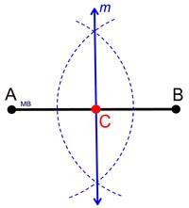  - Draw the given line AB.  - With centre A and any radius greater than half AB draw arcs above and below the line  - With centre B draw arcs of the same radius to cut the previous ones  - The line drawn through the intersections of the arcs will bisect the given line AB at C  PERPENDICULAR LINES  To Construct a Perpendicular at the End of a Given Line  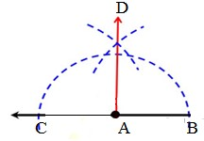  - Draw the given line AB.  - Extend a construction line outwards from A.  - With centre A and any convenient radius draw the semicircle CB.  - Bisect C and B, arcs to intersect at D.  - A line drawn from A through the arcs is the perpendicular (AD) | Questions And Answers  Demonstration  V/E | Taking note of important points  Provide answers
Application | CLASS EXERCISE  - Bisect the given lines  - Construct the perpendicular line to the given points | Questions And Answers | Provide answers
Conclusion | - Recap on the main steps and points | V/E

TEACHER:MWALE CHIPO

DESIGN AND TECHNOLOGY DEPARTMENT
LESSON PLAN

SUBJECT: DESIGN AND TECHNOLOGY CLASS:…… … DATE:……/……./20…. DURATION:………….
BOYS:…………………… GIRLS ………………………………………. TOTAL OF PUPILS… TOPIC: SUBTOPIC:
LEARNING OUTCOMES LSBAT
- Draw tangent to a circle from point p outside the circle
RATIONALE
Knowledge: Construct parallel lines using set square and compass method
Skills: Construction of boarder’s liner and tittle block Values. Awareness of using set square when drawing lines TEACHING AIDS
……………………………………………………………………………………………………………………………………………

PART | LESSON CONTENT | METHODOLO GY | LEARNER ACTIVITY
introductio n | - Recap on the previous lesson | Questions and answers | Provide answers
Developme nt | PARALLEL LINES  Lines that lie in the same plane and do not meet one another  Compass method  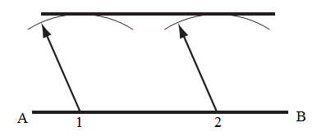  To Draw a Parallel Line  - Draw the line AB. Mark points 1 and 2 near to the ends of the line  - With centres 1, 2 and a radius equal to the distance away of the required parallel line draw arcs.  - A line drawn across the tops of the arcs is the required parallel line.  Set square method  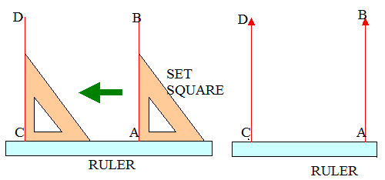  - Position an edge of the set square along the given line, AB.  - Place a ruler against one of the setsquare edge.  - Slide the set square into a new position while keeping the ruler fixed exactly at the same position  - Draw the line CD  - The line CD is parallel to the given line AB. | Questions And Answers  Demonstration  V/E | Taking note of important points  Provide answers
Application | CLASS EXERCISE  - Construct parallel lines using given information  - Set square  - Compass | Questions And Answers | Provide answers
Conclusion | - Recap on the main steps and points | V/E

TEACHER:MWALE CHIPO

DESIGN AND TECHNOLOGY DEPARTMENT
LESSON PLAN

SUBJECT: DESIGN AND TECHNOLOGY CLASS:…… … DATE:……/……./20…. DURATION:………….
BOYS:…………………… GIRLS ………………………………………. TOTAL OF PUPILS… TOPIC: LINES SUBTOPIC: DIVISION OF LINES INTO EQUAL PARTS LEARNING OUTCOMES LSBAT
- Divide line into equal parts using setsquare and compass
- Divide line into equal parts using Ratio
RATIONALE
Knowledge: Construct and dividing a line into equal parts and ratio Skills: Construction of boarder’s liner and tittle block Values. Awareness of using set square when drawing lines TEACHING AIDS
……………………………………………………………………………………………………………………………………………

PART | LESSON CONTENT | METHODOLO GY | LEARNER ACTIVITY
introduction | - Recap on the previous lesson | Questions and answers | Provide answers
Developme nt | DIVISION OF LINES INTO EQUAL PARTS  - To Divide a Straight Line into a Given Number of Equal Parts  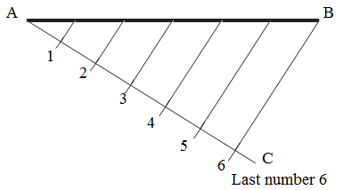  - Draw the given line AB.  - Draw line AC at any convenient angle to AB.  - Step off along AC the required number of divisions. These may be of any convenient length, but equal.  - Join the last number to point B. Draw lines parallel to this line from the other numbers.  - AB is now divided into the required number of equal parts.  DIVIDE LINE INTO RATIO 1:2:4  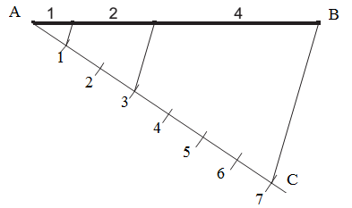 | Questions And Answers  Demonstration  V/E | Taking note of important points  Provide answers
Application | CLASS EXERCISE  - Construct the given lines and divide AB into the following  - 5 equal parts  - 7 equal parts  - Using the ratio 2:3:4 divide the line AB | Questions And Answers | Provide answers
Conclusion | - Recap on the main steps and points | V/E

